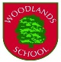
Woodlands School
Privacy Notice

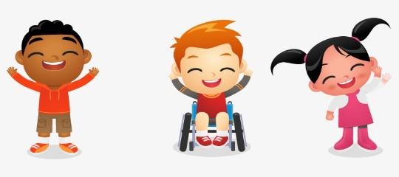

What’s this about?
Our school collects personal details about you and we are a data controller and are in charge of the details we collect and this leaflet lets you know : How we use the details, why we need them, and why and how we look after all the information you give us.
Why do we need to do this?
We do this to keep in touch, keep you safe while you’re in school, to make sure you’re doing ok and to check if you need any extra help, and because it’s the law.
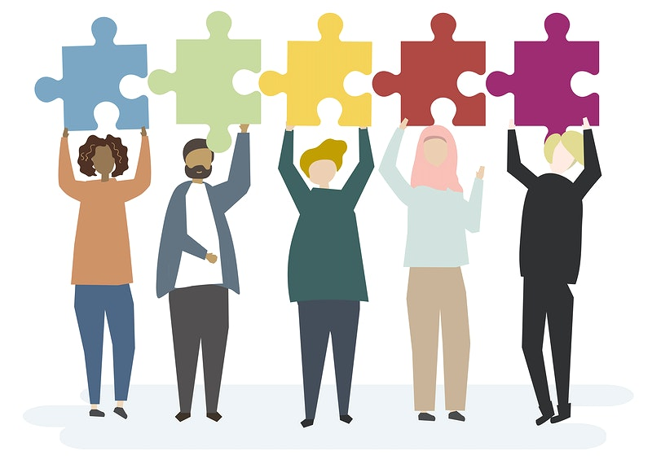
Where do we get the details about you ?
Usually from your family when you start school but sometimes from other schools or people you or your family have contacted to help you.
What details do we collect?
Your name, age, where you live, your family details, what language you speak, pictures of you, your attendance and even if you have any medical or other problems so we can help you. Lots of things that are called personal details.
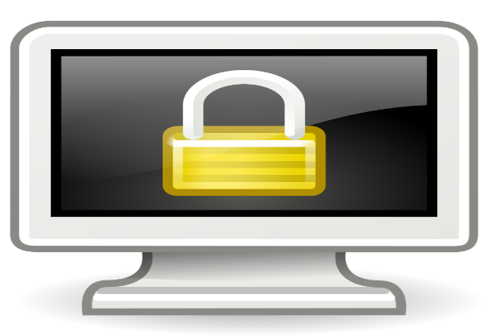
How do we look after it?
We keep it all safe on a computer and sometimes in paper and we make sure it’s all locked up when we don’t need it. Only certain people can see it. We only keep it for as long as we are allowed to.
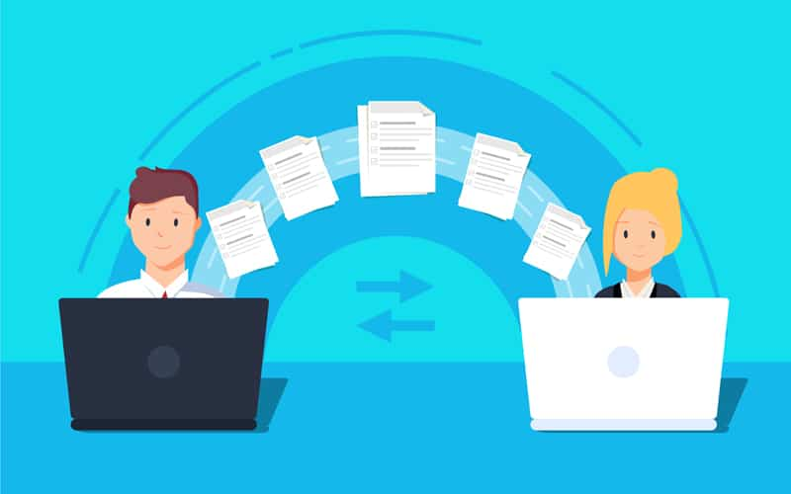
Do we give your details to anyone?
Sometimes we must share your details with other people such as the Government and because it’s the law. We have agreements in place if we do need to share information with anyone else. Otherwise we won’t share your details unless we ask you or your family if its ok but if it means you won’t be safe, we share it straight away.
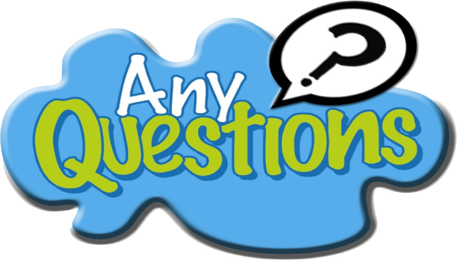
What if I want to know more?
Everyone has rights and you can ask to see what details we have by contacting the Head teacher, Jaci Bates at jaci.bates@torfaen.gov.uk or the data protection officer DPA@torfaen.gov.uk and they will help you.

